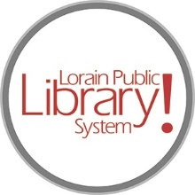

*For more information, contact:*

Anne Godec, Branch Manager

[AGodec@lpls.info](mailto:AGodec@lpls.info)

or

Mark Peters, Assistant Branch Manager

[MPeters@lpls.info](mailto:MPeters@lpls.info)

440-327-8326

[LorainPublicLibrary.org](http://www.lorainpubliclibrary.org/)

**NORTH RIDGEVILLE PATRON UPDATE**

May 21, 2024

Hello friends!

Thank you for following along on our renovation journey. We invite you to come see the results in person:

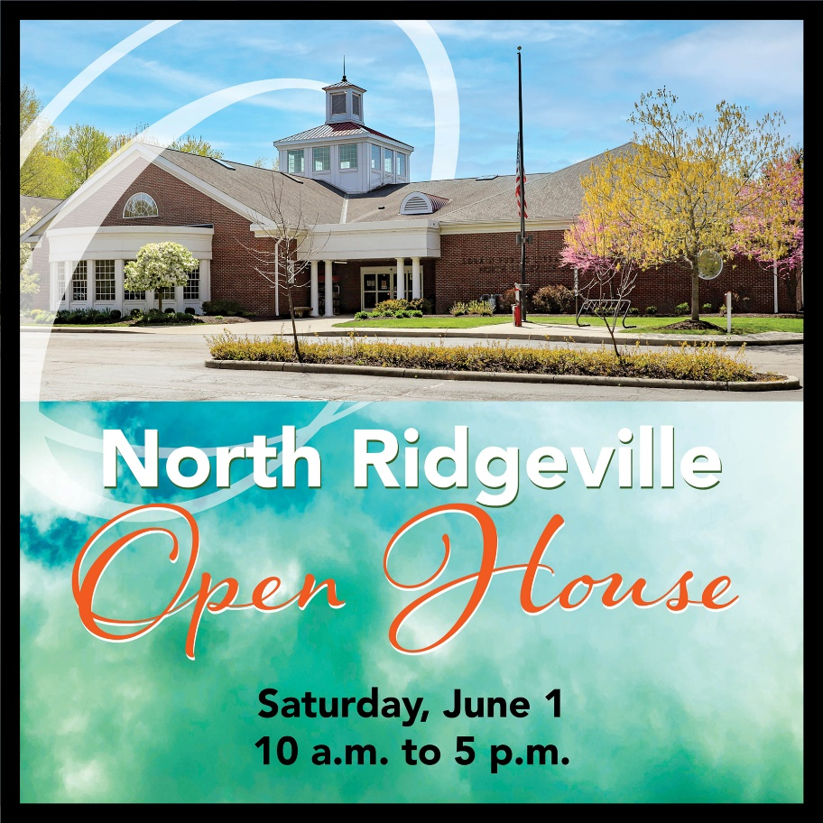

No registration necessary, just a casual open house for our very patient patrons to see the end result of the renovations. There will be refreshments and giveaways while supplies last.

We hope to see you at the library soon.

###